Unit 1: Lesson 4
Positive Actions
Goal: To learn the part “actions” play in the Thoughts-Actions-Feelings Circle. To learn how our actions, lead to our feelings about ourselves.

Story:
Sam’s face was streaked with sweat. He’d drawn an Apollo moon rocket-with a lawn mower. He’d outlined the shape of the rocket and then spent the next half hour mowing the rest of the lawn as fast as he could so he could see if it worked. When Sam was through, he climbed up on the back fence and, sure enough, it looked like a moon rocket to him.
His mom came out to see how he was doing. When she saw the moon rocket in the grass, she smiled and leaned against the fence. “Hey, Sam,” she called, ”next time maybe you could write messages to airplane pilots or mow a dinosaur in the grass!”
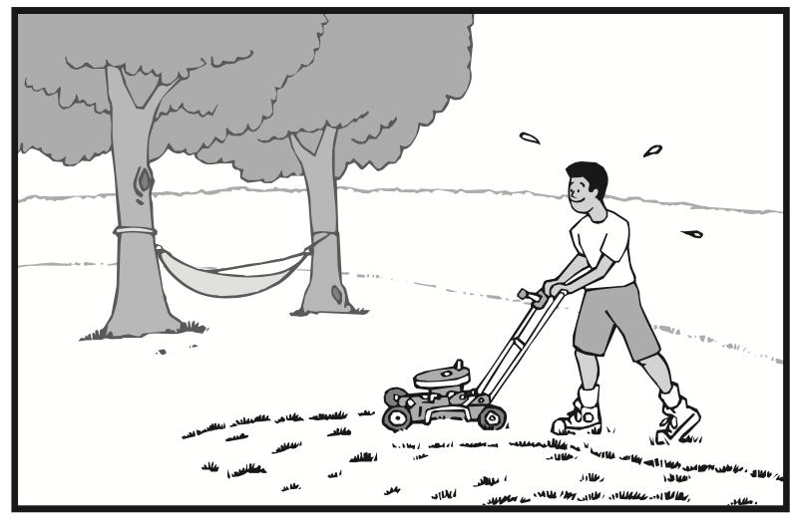
Sam grinned. “Yeah Mom, that would be fun. I’ll mow the moon rocket down later, but I want Dad and Anne Marie to see it first.” Sam started to put away the lawn mower. “You know, Mom, it’s amazing what happens when you just do what you need to do. Sometimes you can even make it fun.”
Sam’s mom smiled and said, “You’re right. You feel good about yourself when you act in positive ways. And sometimes you can make work fun. I’m proud of you, son.”
What we do matters. Positive actions are actions that we do every day to benefit ourselves and others. They are actions such as; eating nutritious foods, exercising, being curious, and creating something unique. They are actions that help us manage our resources well, treat other people the way we like to be treated, tell ourselves the truth, and improve ourselves continually. We can do positive actions in all four areas of our lives – physical, intellectual, social, and emotional.

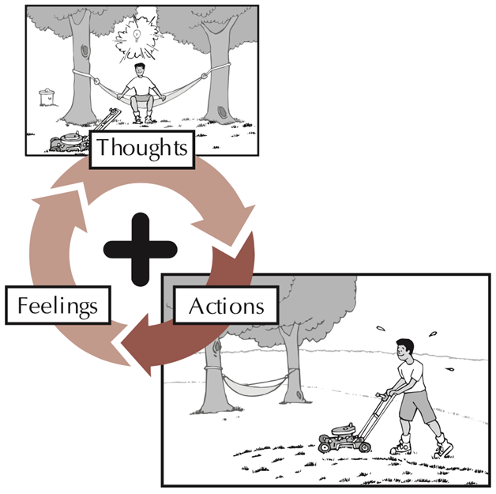
Let’s look at the positive Thoughts-Actions-Feelings Circle again. The program isn’t called “positive thoughts” or “positive feelings.” It’s called Positive Action! There’s a reason for that. Positive actions are central to the Positive Action program. It is what we do that clearly convinces us of who we are.
Our self-concept is formed by what we do, and we have a positive self-concept when we do positive actions. That’s why the program is called Positive Action. The main idea of the program is that we feel good about ourselves when we do positive actions.
It’s what we do that shapes the course of our lives. It’s what we do that forms our self-concept. It’s what we do that makes us happy and successful. It’s what we do that helps us be the best we can be. And it’s what we do that helps other people.
When we do positive actions, we feel good about ourselves. These good feelings about ourselves give us the confidence we need to do other positive actions. When we do positive actions well, we feel even better about ourselves and gain even more confidence in ourselves.
We need to do positive actions not only because our positive actions affect how we feel about ourselves, but also because they affect others around us in positive ways. The effects of our good deeds ripple out to others and just keep going. Its important that other people know that they can count on us as positive persons.
When we do negative actions, they also affect others but in negative ways. For instance, if we refuse to learn new things: if we harm ourselves by using substances such as alcohol, tobacco, or other drugs; or if we don’t treat others the way we like to be treated, we harm others as we harm ourselves, and we don’t feel good about ourselves.
Negative actions happen easily. At times it seems easier not to tell the truth, or not to eat healthy food, or not to exercise. Sometimes we are treated negatively by others or we think the situation is unfair. We usually have a first response, which tries to take the easy way, and sometimes that way is negative. That’s why it’s important to remember that no matter what, the situation is not hopeless, and we are not helpless. There is a positive way to do everything, and we can choose it! Especially with actions, there is no middle ground. We need to think about our first response in order to make it something positive.
Positive actions usually take more effort than negative actions do. Positive actions require more time, energy, honesty, and confidence. They need to be deliberately selected, and they require follow-through. They take doing. Not only do we feel good after we do positive actions, but often we feel good about ourselves while we do them. We get a sense of joy and satisfaction about our lives when we do positive actions.
All positive actions are meaningful. While we won’t master every positive action to be taken in all areas of our lives, we can gain confidence in our ability to do positive actions no matter what comes our way. The more we do positive actions, the easier they are to do and the closer we come to being the best we can be.
Positive actions come from positive thoughts. When Sam chose how he was going to think about mowing the lawn, he chose to think positively. Sam found a way to make mowing the lawn exciting and fun. Remember, there is a positive way to do everything!

Questions:
- What are positive actions?
- How do our actions affect us?
- How do our actions affect others?
- Why are positive actions harder to do?
- What do our actions lead to in the Thoughts-Actions-Feeling Circle?
- Why do we get joy and satisfaction from doing positive actions?
- What do our negative actions lead to?
- What are some examples of negative actions you do?
- How do you feel about yourself when you do negative actions?
- What are some examples of positive actions you do?
- How do you feel about yourself when you do positive actions?

*Pick a person for whom you would like to do positive actions. Don’t tell anyone who you have selected, and don’t let the person know. Do as many positive actions as you can for that person this week. What are some things you could do? Make a plan. Maybe you could: Pack a lunch; leave positive notes or drawings; help with chores.
Family Questions:
- How do positive actions affect our family?
- How do negative actions affect our family?
- When we do positive actions as a family, how do they affect each of us?
- What positive actions could we do as a family to improve our family’s self-concept?
Parent postive actions

Ask Yourself: Are your actions toward your children more positive or more negative? What positive actions do you do for your children? What are you teaching your children when you do positive actions? Why do you want to teach your children to do positive actions? What positive actions are you already teaching them?
Plan and Do: Choose a positive action you would like to do for each of your children this week. Think about each one and what he or she needs. Take ages and interests into account. As you choose your positive actions, keep in mind your children’s special interests such as sports, music, or animals. Do the positive actions for your children.

Now let’s choose some positive actions we can do as a family. Let’s make this a family project, a fun, positive experience that involves everyone. For instance, we could:
- Exercise every day for a week. We could go for a walk every night or shoot hoops. Maybe we could all play hopscotch or ride bikes.
- Learn something new. We can all decide on something we want to learn about. Maybe we want to learn about moon rockets or dinosaur bones. We can find information at the library, on the internet, or we can rent videos and then share what we know.
- Hold a Positive Day where only positive things are said to one another. That evening, if we like, we could go around the dinner table and say positive things about the person on our left.
- Have a Pitch-In Activity where we all agree to pitch in to wash the windows, clean up our homes, paint a room, or do whatever needs to be done.
- Let’s make sure our activities involve everyone and that they are positive!

Community Positive Actions:
Let’s plan to practice positive actions for the community. Consider a positive action that could create goodwill and friendship in our neighborhood. Perhaps we could do something nice for one of our friends or neighbors – invite him or her to dinner, pull weeds, pick up litter. Perhaps there are other positive projects in our community that need to be done.
When people work together for snow removal, graffiti control, or to fill up dwindling food banks, everyone in the community benefits, including the people taking action. Doing positive actions in our community gives us a good feeling and a sense of belonging.

We feel good about ourselves when we do positive actions. Positive actions are the good deeds we do to help ourselves and others. They are a result of the positive thoughts we choose. They also help us feel good about ourselves, and they work to form our self-concept. We have a positive self-concept when we do positive actions. It’s what we do that convinces us who we are. Our positive actions convince us that we can feel good about ourselves. Positive actions are central to the Positive Action program.
The more we do positive actions, the more confidence we have to do even more! It’s what we do that makes the difference in our lives. It’s what we do that shapes the course of our lives. It’s what we do that makes us feel good about ourselves or not feel good about ourselves. What we do matters!

Word of the Week: Happiness
To feel good about who you are, what you are doing, and how you treat others.

